Joint Probabilities Exercise

In class, we introduced the method of using the "Receiver Operating Characteristic" (ROC) to determine how sensitive a neuron was to a given stimulus parameter. In this exercise, we will first compute the ROC and then compare the result to a different approach in the context of a 2-alternative forced choice task (2AFC).

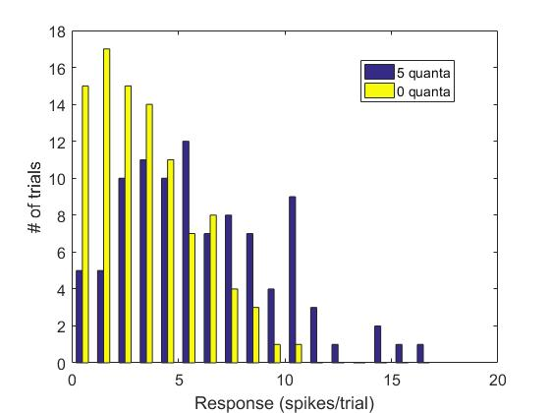
The following figure shows a histogram of responses of a single retinal ganglion cell to pure noise (0 quanta, red) vs. a signal of 5 quanta of light (blue). The data is taken from a paper by Barlow et al. 1971.

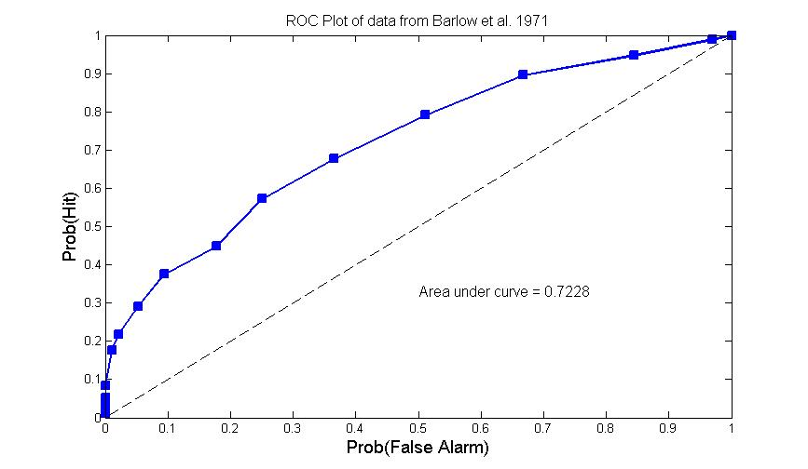
ROC Method. We want to know how well an "ideal observer" ("ideal" because she has access to all of the statistics contained in the two histograms) could distinguish signal from noise. Conceptually this amounts to adopting different "criteria"—that is a number of spikes at or above which we would declare that a signal was present. For example, if we adopted an extremely strict criterion of 17 spikes we would correctly declare a "hit" (i.e. signal present) only 1 time out of the total of 96 blue trials, for a "hit rate" of 1/96, or 0.0104. We would never declare a signal to be present when it wasn't (a "false alarm"), because there are no yellow bars to the right of 17. This gives us two values, 0.0104 and 0, which constitute one point on a plot of "hits" vs. "false alarms." We then repeat this procedure for all possible criteria from 17 to 0, each time sliding one to the left and calculating our "hits" from the blue distribution and our "false alarms" from the yellow one. At the end of this procedure we have a plot that looks like this:

The area under the ROC curve is our measure of "performance"—but what does it mean? At one level, we can just think of it as a non-parametric measure of how well separated the two histograms are. For example, if the two histograms were completely overlapping, we would always measure the same values for hits and false alarms regardless of the criterion, thus putting all points on the diagonal and getting an ROC area of 0.5. If, on the other hand, the two histograms were completely non-overlapping, our points, as we moved away from the strictest criterion, would crawl up the left-hand y-axis, then across the top of the box to give an ROC area of 1.

Joint Probability Method. But we can think of these data in another, more psychophysical, way. Consider now a 2AFC game in which we are presented, on each “trial,” with two measurements, one of which was drawn from the 5-quanta (blue) distribution and the other of which was drawn from the 0-quanta (yellow) distribution, and we are asked to decide which measurement came from the blue distribution.

Looking at the two distributions, the only reasonable decision strategy would be to assign the larger response to the signal (5 quanta) and the smaller response to the noise (0 quanta). If both responses are the same size, we have to guess (for instance, by tossing a coin).

How often will we get the correct answer? We can answer this precisely by looking at joint probabilities. We know from our data what the probability is of getting, for instance, a single spike response with 5 quanta of light: It happened in four trials out of 96, so the probability is 0.0417. If we have two measurements, we are interested in the joint probability: for instance, what is the probability of getting 4 spikes from the blue distribution AND 2 spikes from the yellow distribution? We can compute the joint probabilities by multiplying the single probability distributions.

In our case, this is what the joint probability distribution would look like:
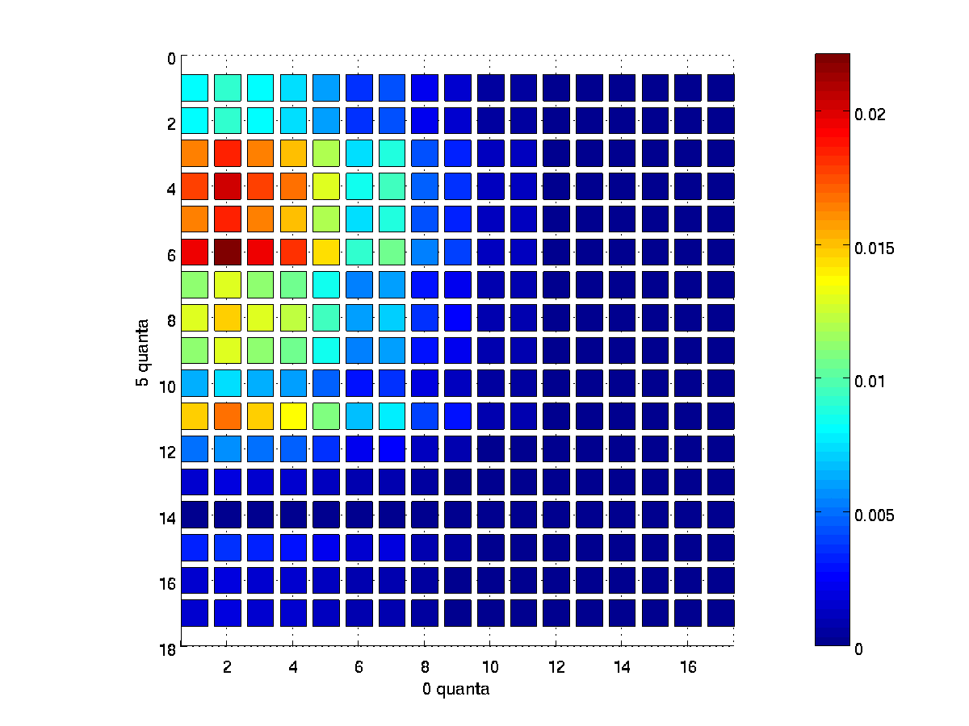

Each position in the table is colored according to its value. This makes it easy to see, for instance, that it is most likely to get between 0 and 11 spikes with the stimulus (blue), and around seven spikes or less with the control (yellow). (Check with the histograms shown at the beginning to see whether this looks right.)

We can now read all of the joint probabilities directly from this table. For instance, we can look up the probability of getting 4 spikes from the blue distribution AND 2 spikes from the yellow (in this case, the probability is 0.0203).

In order to see whether our decision rule (assign the bigger number of spikes to the signal) is any good, we need to determine how likely it is to get more spikes with signal than with noise. That is, we are interested in the lower triangular part of the joint-probability table.
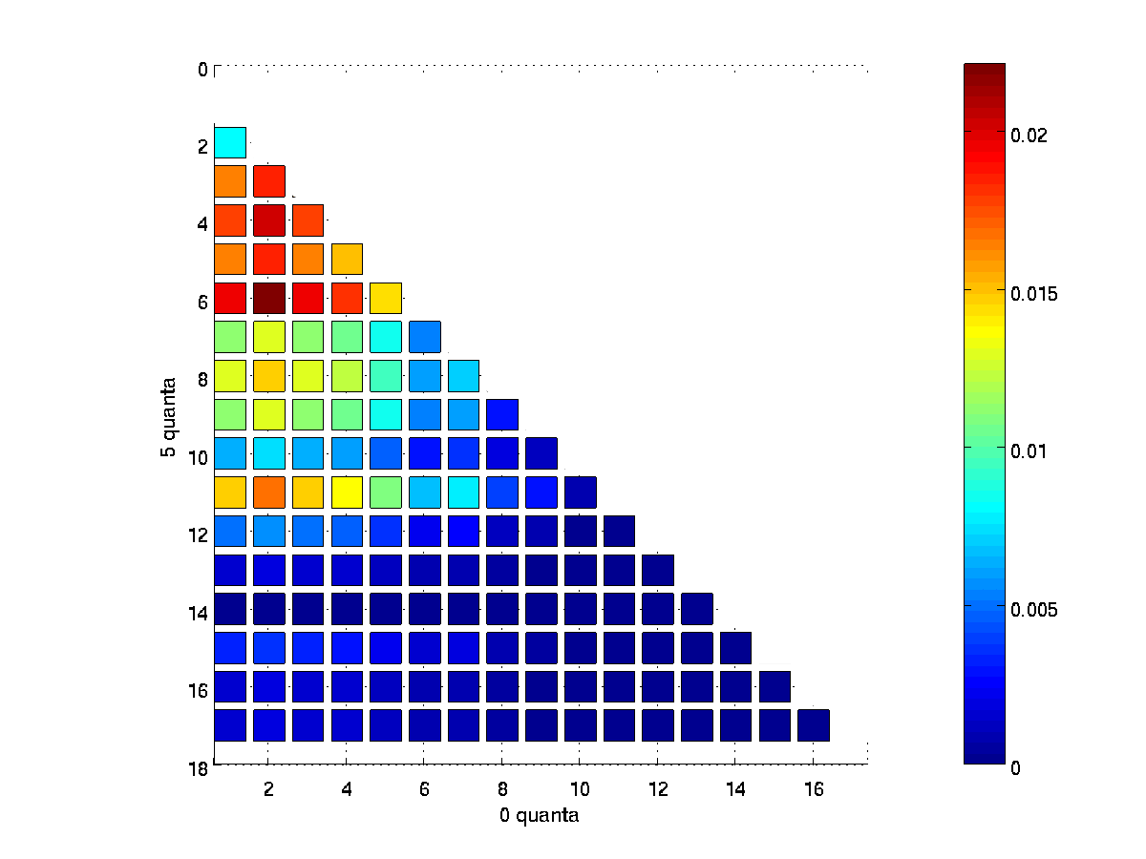
Summing over all of these will give us the total probability of getting a higher spike rate from the signal than the noise distribution.

In addition, if both samples are the same spike count, we have to assign them to signal vs. noise at random, and if we do that, we will be correct, on average, 50% of the time. So, to the sum of the probabilities in the lower triangle, we add ½ times the sum of the probabilities along the main diagonal and thus get the overall probability of getting it right.

Green and Swets (1966) showed that the result of this method is equivalent to the result obtained by using the Receiver Operating Characteristic (ROC).

References:

Barlow HB, Levick WR and Yoon M (1971) "Response to single quanta of light in retinal ganglion cells of the cat" Vision Res. Supplement No. 3, pp. 87-101.

Green DM and Swets JA (1966) Signal Detection Theory and Psychophysics. New York: Wiley. (ISBN 0-471-32420-5)

Exercise:

We will go through the process of computing and interpreting the joint probabilities in MATLAB using a real data set. The data is from a paper by Barlow et al. 1971. We are going to look at the dataset from figure 1B, which is given in the file BLY.txt

If you are experienced with MATLAB, try and see whether you can compute the neuronal performance using joint probabilities by going through the above explanation. (For extra credit, use the description above to implement the ROC calculation and see whether both give you the same answer.) If you have less experience, the following steps will help guide you through the exercise:

Step 1: The dataset is in the file named BLY.txt. Load it into MATLAB using the load function. What does the dataset look like? What are the rows and columns?

Step 2: Each entry in the dataset is a spike count from a single trial (5 quanta in the first column, 0 quanta in the second). We want to see how many times a particular spike count showed up in this column. How would you collate this data? Hint: The hist function is useful both for visualizing the data, and for working with it, since the outcome of hist can be stored in a new variable. How would you find the optimal number of bins?

Plot a histogram of the signal and noise distributions as in figure 1.

Step 3: From a list of frequencies of each spike count, we want a probability density function, i.e. we want the area under our histogram to sum to 1. Normalize the data accordingly. How can you check that the values in each of your new probability density functions do indeed sum to 1?

Step 4: You now have the probability distribution for the 5-quanta case and the probability distribution for the 0-quanta case. Generate a joint probability distribution. Hint: type 'help *' at the MATLAB prompt.

Use 'imagesc' to display the joint probability matrix as in figure 3.

Step 5: From the joint probability matrix, compute the 2AFC performance by taking the sum of the lower triangular part of the table plus half the sum of the diagonal. Hint: Look for help on the tril and diag functions.
Step 6: What is your answer? What do you conclude about the quality of the decision rule?

Your assignment is to write a MATLAB script to implement the % correct 2AFC calculation using joint probabilities as described above. Please name your script "BLY_yourlastname.m". For example, my script would be "BLY_Born.m".

Version History:
MIS wrote this, 03/07/2014
RTB added ROC description and figure, 3/09/2014

